

**GBUS- 721: MARKETING RESEARCH**

**Prof. Fatena El- Masri**

**VEGA-ICE**

**Team Members**

Shreya Reddy

Keerthi Gollamudi

Sai Chaitanya Sadasivuni

Table of Contents

1. ABSTRACT 3

2. INTRODUCTION 4

3. OBJECTIVE 4

4. PROBLEM STATEMENTS 4

5. ABOUT VEGANISM 5

6. MARKET ANALYSIS 6

6.1 Ice cream market analysis 6

6.2 Vegan ice cream market 6

7. STEPS OF MARKETING RESEARCH 7

7.1. Defining research problem and objectives: 8

7.2 Develop the approach 9

7.3 Research design 9

7.4 Data collection and processing 10

7.5 Data analysis 12

7.6 Market research report and presentation 13

8. DATA VISUALIZATIONS 15

8.1 Gender vs. Ice cream preference with age 16

8.2 Interest in V-Ice vs. Age 17

8.3 Flavors vs. Age 18

8.4 Age and time in a day 19

8.5 Quality, Gender vs. time, price 20

8.6 Location vs. Age 21

8.7 Competitors in Ice cream industry 22

8.8 Age range vs. Base 23

8.9 Availability vs. Interest in V-Ice 24

8.10 Choice of Toppings vs. Age range 25

8.11 Milk base vs. Gender 26

8.12 Promotions vs. Gender 27

8.13 Interest in V-Ice vs. Quality, Promotions and Price 28

9. NEW FLAVOR IDEAS 29

9.1 Cotton candy 29

9.2 Bubble gum 29

9.3 Pumpkin spice 29

9.4 Paan ice cream 29

10. FINAL RECOMMENDATIONS 30

11. LIMITATIONS 31

12. CONCLUSIONS 31

13. REFERENCES 32

## ABSTRACT

The centers for disease control and prevention (CDC) reports that nearly one in three Americans has high cholesterol. When a person has too much bad cholesterol in the blood, it is a major risk factor for heart diseases and might cause cardiac attacks. Countless studies indicate that a vegan diet directly results in a low cholesterol level. Not just high cholesterol, people who suffer from either dairy allergies or lactose intolerance primarily adopt veganism to avoid dairy intake.

This Marketing research project would be on introducing a vegan ice cream called *Vega-Ice* and the unique selling point of this product is that there are new and interesting flavors, such as cotton candy, bubblegum, pumpkin spice and pan ice cream (primarily made with leaves which are well known in the Indian subcontinent). Vega-ice is mostly made out of soymilk, nut milk, or coconut milk which is lauded by the vegan community.

Whenever Vegans are looking for a cool, sweet treat but cannot have a regular ice cream, Vega-Ice would be a great choice. Vega-Ice also has health benefits over a regular ice cream. It works as an all-natural energy booster too. Hence, we can conclude that Vega-Ice is not limited to only vegans but also can be consumed by all kinds of ice cream lovers who wish to try interesting flavors. Our research work would be on the flavors that are most lauded by the consumers (vegan and non-vegan). Our focus is primarily on Vega-ice being a class apart from the other brands.

## 2. INTRODUCTION

Thousands of years ago, Marco polo returned to Italy from the far east with the recipe that we call today as a sorbet. This has laid a foundation for that delicious and creamy dessert that is named as ice cream in the 16th century. Ice cream is a sweetened frozen food that is loved by most people all over the world as a snack or as a dessert.

The word “ice cream” has various meanings around the world, in some countries, it is also termed as "frozen custard," "frozen yogurt," "sorbet," "gelato". All of these have different textures and different styles. The primary ingredient remains constant that is the creamy base which is derived from dairy products such as goats or sheep's milk or non-dairy milk such as soy, cashew, coconut, almond milk.

Ice cream is considered a colloidal system. It is composed of ice cream crystals and aggregates, the air that does not mix with the ice cream by forming small bubbles in the bulk and partially coalesced fat globules. This dispersed phase made from all the small particles is surrounded by an unfrozen continuous phase composed of sugars, proteins, salts, polysaccharides, and water. Their interactions determine the properties of ice cream, whether soft and whippy or hard. (Ice cream, n.d.)

## 3. OBJECTIVE

Introducing new vegan ice cream flavors which attract all age groups and also to decrease the fat content and sugar levels in an ordinary ice cream to provide a great dessert experience. This product would help promote veganism to masses and also would benefit the health and hygiene of the consumer.

## 4. PROBLEM STATEMENTS

1. Which age group is interested in vegan ice cream?
2. What is the current evaluation of the vegan ice cream market?
3. Is vegan ice cream an easily available commodity?
4. Which non- dairy ice cream base is preferred by the masses?
5. Is the vegan ice cream business a reliable industry for growth in the next 10 years?
6. What flavor choices are the consumers most interested in?

## 5. ABOUT VEGANISM

There are various reasons for opting for veganism in today’s world, some of which are listed below

* For the planet
* For the health
* For the people
* For the animals
* Religious beliefs
* High cholesterol levels

Going vegan is a great opportunity to learn more about nutrition and cooking and improve your diet. Getting your nutrients from plant foods allows more room in your diet for health-promoting options like whole grains, fruit, nuts, seeds, and vegetables, which are packed full of beneficial

fiber, vitamins, and minerals.(Why go vegan?, n.d.)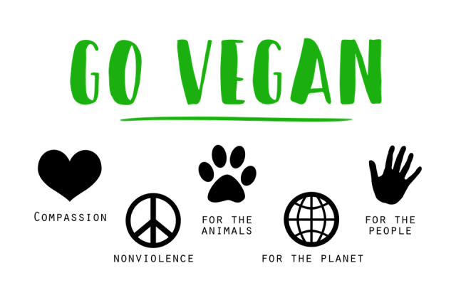

(abillionveg, 2020)

## 6. MARKET ANALYSIS

### 6.1 Ice cream market analysis

The Global Ice Cream Market was valued at $68,072 million in 2016 and is projected to reach $97,301 million by 2023. This talks volumes about how promising this industry has proven to be over decades and will be in the future too. The variety of ice cream has always excited and impressed individuals of all ages. This product has seen immense growth during summer every year. The growth of this industry has undoubtedly increased the number of varieties and flavors that are available in the market which in turn contributes towards the revenue of the market.

Manufacturers are increasing their product range by including functional ingredients, organic herbal fillings, and exotic flavors in product formulations to meet the changing consumers’ demands. For instance, companies are including other exotic flavors such as tropical fruits, lemons, and coconuts to cater to the changing taste of consumers. In addition, health-conscious customers prefer a low-calorie and low-fat ice cream called Skinny Cow. (Deshmukh, 2017)

### 6.2 Vegan ice cream market

A renowned market research firm Technavio has released a report that highlights the increase in the vegan ice cream market from 2018 to 2022. In this report the researchers predicted that the vegan ice cream market would be having a substantial increase of 9% annually and also that the US market consists of 45% of the global share. Researchers also believed that this growth is caused due to the increase in the global vegan population and which was particularly observed in the millennial demographic. The growth in vegan population has caused a direct increase in the consumption levels of vegan ice cream.

In developed countries like the US, the demand for vegan ice cream is increasing because few brands have also come up with new flavors with various milk bases which not only attracted millennials but also people of all ages. Non-vegan brands such as Ben & Jerry’s, Breyers, Haagen-Dazs, and [Halo Top](http://vegnews.com/articles/page.do?pageId=10736&catId=1) have introduced dairy-free ice cream lines to capitalize on the growing vegan ice cream industry—which is [predicted](http://vegnews.com/articles/page.do?pageId=9816&catId=1) to be worth $2.45 billion by 2027.

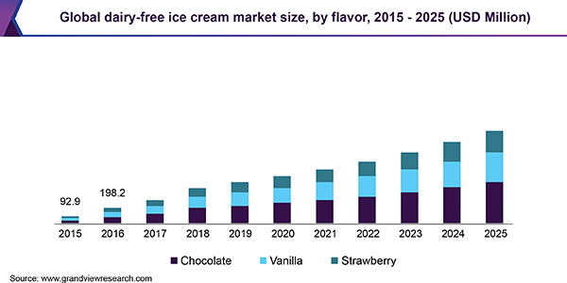

## 7. STEPS OF MARKETING RESEARCH

We have followed the six traditional steps to conduct our research in marketing our product. The six steps include:

* Defining the research problem and objectives
* Develop the approach
* Research design
* Data collection
* Data processing and analysis
* Market research report and presentation

Now, we will give an in detailed knowledge of how we proceeded with each module.

(Guy, 2020) 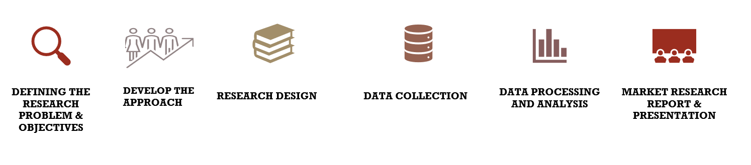

### 7.1. Defining research problem and objectives:

This is the first step in the process where we had to start everything from scratch by digging into the problem we have in the existing products. Also, we’ll be discussing the objectives of the product which we’re planning to launch, and how it would overcome the problems of the existing ones. The following are the research problems that we have identified with the existing dairy/vegan ice cream products in the industry.

#### 7.1.1 Fat and sugar content

There are so many people who are pretty much concerned about their health and being diet conscious and having an ice cream having fats and more sugar content will not help them. This is what we considered as a primary drawback with the dairy ice creams and treated it as an advantage. Later in this report, we will be listing how our product Vega-ice will be advantageous for these groups of people who would want to restrict the fat and sugar content.

#### 7.1.2 Lactose intolerance

Lactose intolerance is a digestive disorder caused by the inability to digest lactose, the main carbohydrate in dairy products. This is one of the reasons why most of the people move towards non-dairy products. With Vega-ice, we assure the best quality of vegan ice cream which tastes as good as a dairy ice cream with no side effects.

#### 7.1.3 Unavailability of vegan ice creams

As discussed, the ones who love the taste of ice cream and are affected with dairy allergies and lactose intolerance have no option other than fulfilling their ice cream cravings with ice creams that are vegan. This way, so many people adopt veganism for multiple reasons such as religious beliefs, health issues, and many more. There are vegan ice creams available in the market but not as many as the dairy ice creams. Our goal is to make the vegan ice creams equally available in the market as the dairy ice creams are.

#### 7.1.4 Unavailability of interesting flavors

We have conducted research on the existing vegan ice creams by walking into the ice cream store and checking the options available for vegans in ice creams. Sadly, there were so many repetitive and common flavors. Baskin Robin, Ben & Jerry’s had non-dairy chocolate flavors, mint chocolate, cinnamon buns, and many more. Haagen-Dazs had non-dairy caramel and chocolate flavors as everyone had, but they experimented by trying to make lemon sorbet and couldn’t reach up to the mark. We have aimed to introduce new flavors that were never there in vegan ice creams.

### 7.2 Develop the approach

To achieve the goal of our project, we have developed an approach in which we followed 3 steps out of which we consider one as most important. The three steps include Human survey reports, research about the ice creams in the supermarkets, and ice cream stores. The main marketing approach for our product was to match the tastes and preferences of our customers. The one feasible way we found to do that is by conducting a survey and taking it to the people all across the globe.

Another approach that we felt it might work is by walking into the supermarkets and ice cream stores, speaking to the store managers, explaining to them our survey, and taking general data from them related to what kind of ice cream they sell the most and what age grouped people walk into their stores and many other key points which we used to check with the data we got.

### 7.3 Research design

After getting to know what the customers usually look for in ice creams, we focused on including those questions to which the survey takers would be more interested in letting us know their preferences. In this module, we will be explaining our design and plan for data collection. Our survey is unbiased, we designed it in a way that every ice cream lover would want to take it. The survey questionnaire follows a section based approach starting with basic demographic questions such as age and gender followed by our primary question asking the survey takers for their interest in the what type of ice creams do they prefer ( dairy or non-dairy), including other questions such as how much are they willing to pay per scoop, what interesting flavors would they like to try by providing few new flavors as a choice with flexibility for survey takers to specify what interesting flavors do they want to have in the market along with the topping choices.

We also asked them where they usually get their ice creams from so that we’ll have an idea of where we have to start the launch of our product. Our goal is not just to enter the ice cream industry just as another ice cream brand, but also to promote veganism through our products. So, we also asked the survey takers who like to prefer a dairy ice cream, if they are interested in trying vegan ice cream. Surprisingly, more than 70% of the responses said that they are interested in trying the vegan ice cream which made us feel that there is an advancement towards the reduction of an individual’s carbon footprint which would in turn reduce the environmental impact on a larger scale if implemented. Vegan ice cream can be made out of any natural milk extracted from nuts, seeds, grains, plants. There is a variety of non-dairy milk out of which there are few types of milk such as coconut milk, almond milk, soymilk, and oat milk that can be used to make vegan ice creams. We provided these non-dairy milk bases as options and collected the interests of the customers to know what kind of milk they’d like to have their vegan ice cream prepared with. Finally, we wanted to focus on the parameters most of the customers give importance to. Through a matrix table, on a scale of 5 we asked the customers to rate for the parameters such as price, quality, and contents of the ice cream, occasion, new flavors, and how much impact promotional offers on ice cream would make.

Survey Link : <http://gmusom.az1.qualtrics.com/jfe/form/SV_9KYqU3bTkgT9PmJ>

### 7.4 Data collection and processing

Now that we have our questionnaire, we are ready to advance to the next step in the process of marketing research where we had to select a medium where we can perform the data collection process (collection of the survey responses), for that we have made use of the Qualtrics surveying tool which is an American experience management company which helped us structure our questions in a format, keep a count of responses and retrieving them once the expected count has been achieved.

By performing the data collection process, it helped us in identifying and analyzing the current market trends and opinions of different people. After collecting the data, we have exported the data into an excel file to proceed with our further analysis and research. We got 217 responses from the survey. Each question in the survey represents a column in our dataset.

The below snippet is our input file before data cleaning:

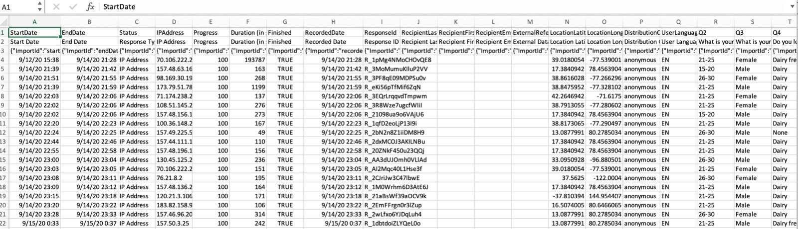

Data cleaning consists of handling the missing values and also to edit spaces and multi value entities, removing duplicates, finding mis-spelled words and correcting them etc. The following snippet depicts the view of the excel sheet after the data cleaning has been done successfully.

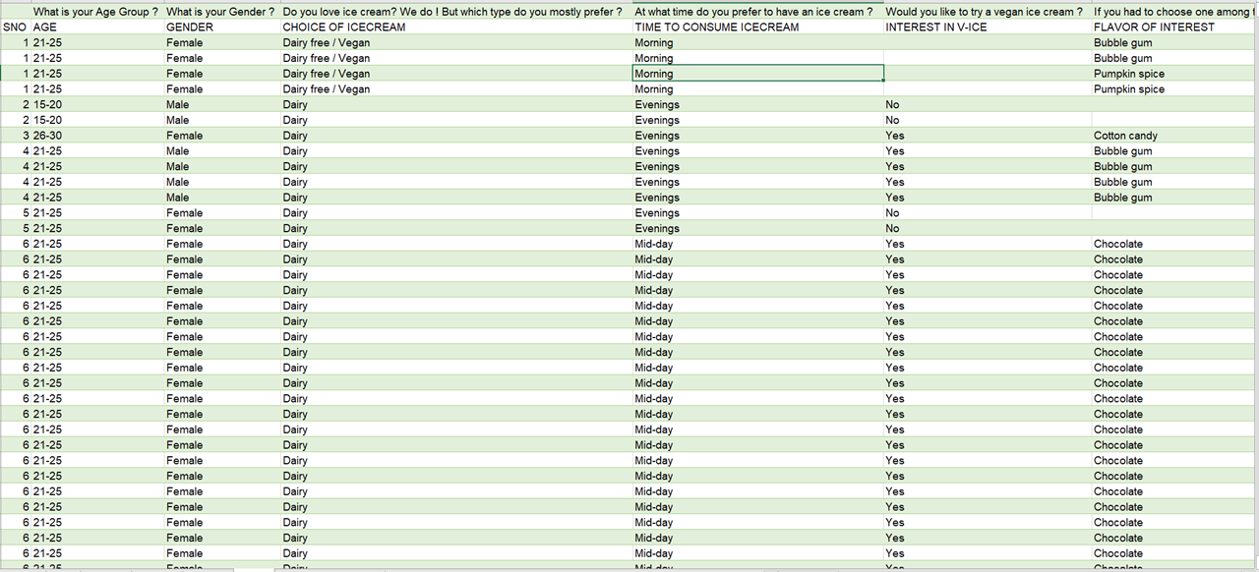

### 7.5 Data analysis

After data collection, processing, next comes data analysis. The type of data is very important before starting the analysis. We have 14 attributes after cleaning, and they will be discussed in detail.

#### 7.5.1 Attributes and their definitions:

* **Age**: According to the survey questionnaire, we have 6 categories of ages which start with the age group 15-20 (adolescents), 2 ranges in young adults from 21-25 and 26-30, people between 30 and 41, the middle-aged group from 41 till 50, and the last group above 50 years.
* **Gender**: There are many visualizations sorted using the gender attribute. This variable has been so helpful in educating us about the gender-wise preferences for multiple parameters affecting the sale of ice creams such as price, quality, offers, and many more.
* **Choice of ice cream**: There are 2 types of ice cream which are mainly preferred, dairy, and non-dairy. As already stated, we are not just trying to impress the vegans with our non-dairy ice creams, but also trying to promote veganism to the dairy community. To analyze the choice of ice cream, we had to pull this data from our survey takers.
* **Time in a day to consume ice cream:** There is no particular time in the day people like to have ice cream. It might be in the mornings, mid-days, evenings, mid-nights. Pooling this data helps us by providing the information which might help our business grow through advertising during the time in a day when ice creams are mostly consumed and also with other advantages.
* **Interest in Vega ice**: Be it a dairy or non-dairy ice cream lover, we wanted to check how interested the customers are interested in trying a vegan ice cream.
* **Flavor of interest**: Our key intention is to introduce new flavors which we never had in the market before. We will definitely have all the new generation and old school flavors on our menu, but we treat a few flavors as special ones.
* **Non-dairy milk base**: We have a variety of non-dairy milk bases that we can use in making ice cream, but we want to go with the customer’s choice in the milk bases. So, we thought of gathering this data.
* **Toppings choice:** Most of the people love piling the toppings on their ice creams. So, we wanted to have the knowledge of which toppings customers would love to have.
* **Is availability of interesting flavors in vegan ice creams easy?:** This attribute gave us a crucial piece of information fueling our primary intention to bring out new flavors into the ice cream industry that tastes so natural.
* **Is vegan ice cream overpriced?:** Many people are under the misconception that vegan ice cream is overpriced. But we wanted to know to what extent it is valid.
* **In what do you want your ice cream served in?** This attribute helped us to know about the customer’s preference of having the ice cream in a cup/cone/waffle and so on.
* **Place of purchase**: You know where to get your ice cream. We want our ice creams to be available for you wherever you go. So, to make our products easily available, we would want to know where our customers would walk in to buy their ice creams.
* **Ice cream brands that are previously purchased**: Before launching our product, we wanted to know who our competitors are in the existing ice cream industry.
* **Price per scoop**: How much are you willing to pay for an ice cream scoop? Isn’t that important? Remember, we want to sell ice creams for everyone. So, it is going to be super affordable with cheap topping prices. But before that, we need the data about how much you spend on ice creams.

### 7.6 Market research report and presentation

The final step is analyzing the data. Once the data is cleaned, we have analyzed it to draw some useful conclusions out of it. We have also used excel for descriptive analysis by constructing pivot tables. In addition to that we have also used tableau to construct some visualizations by considering the parameters such as age, gender, ice cream toppings, non-dairy milk base, the flavor of interest, interest in vegan ice cream, and so on.

#### 7.6.1 Pivot tables

*Table 1: Non-Dairy Milk Base vs Age & Gender*

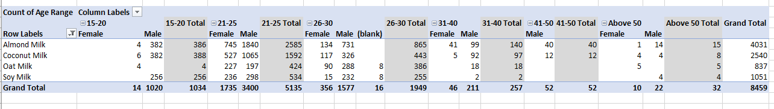

From this table, we can say that Almond Milk is preferred most by all the age groups.

*Table 2: Promotions Vs Age group*

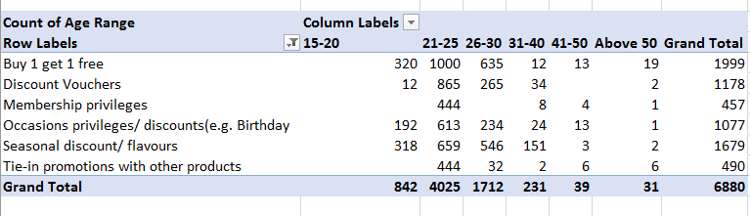

From this pivot table, we can say that 21-25 age group people are more interested in promotions. Also, most of the people are interested in Buy 1 get 1 free promotion followed by Seasonal discounts/flavors.

*Table 3: Base vs Gender*

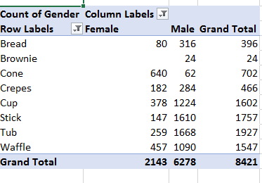

This table says that the majority of people prefer to have their ice creams in Tub followed by stick, cup and waffle.

## 8. DATA VISUALIZATIONS

We made use of all the variables and parameters effectively from the data gathered to address the problem statements stated in the beginning, to show the demand and interest people have towards vegan ice creams sorted according to age and gender, and many more attributes. We have used the following listed charts and graphs to interpret to understand the survey results, data better, and to interpret conclusions for our new ice cream brand VEGA-ICE. The graphs used in this research are as follows.

* Bar graph
* Tree maps
* Bubble charts
* Horizontal bars

We made a proper use of excel to clean the data as already discussed above, so that we can work with it easily using Tableau. We were able to successfully perform the visualizations on Tableau and get the desired visualizations as shown below.

### 8.1 Gender vs. Ice cream preference with age

The below visualization depicts that most males prefer having a dairy ice cream over a dairy-free ice cream. Females also do prefer dairy ice creams but the difference between the number of people who chose dairy and the number of people who chose dairy-free is significantly less. So, from this visualization, we can say that both females and males preferred the dairy most and we can also say that the people within the age group 21-25 are more interested in both dairy and non-dairy when compared to the other age groups.

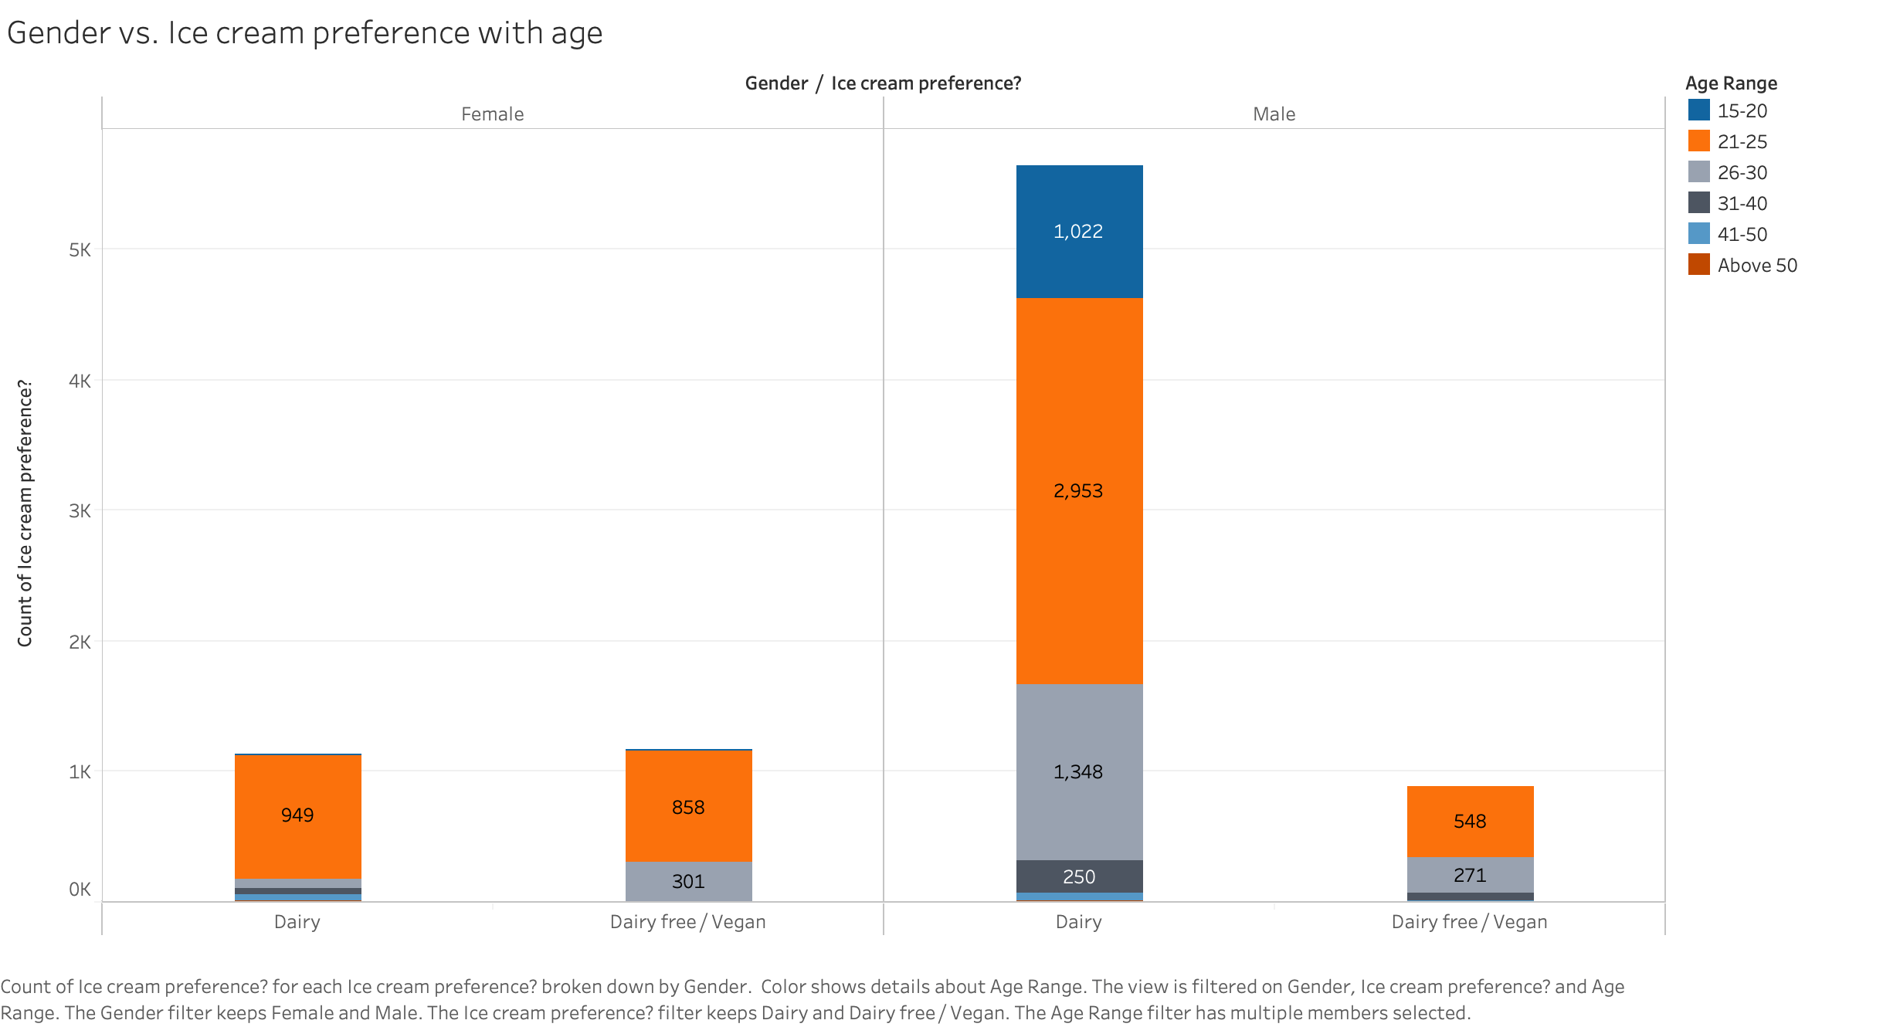

### 8.2 Interest in V-Ice vs. Age

The below visualization is one of the most important visualizations which has paved the way for our further research and analysis. This visualization contradicts our previous visualization because, even though both females and males have preferred dairy over nondairy, a huge number of people are interested in trying vegan ice cream. And among all the age groups who are part of the survey, the 21-25 age group people are more interested in trying the vegan ice cream.

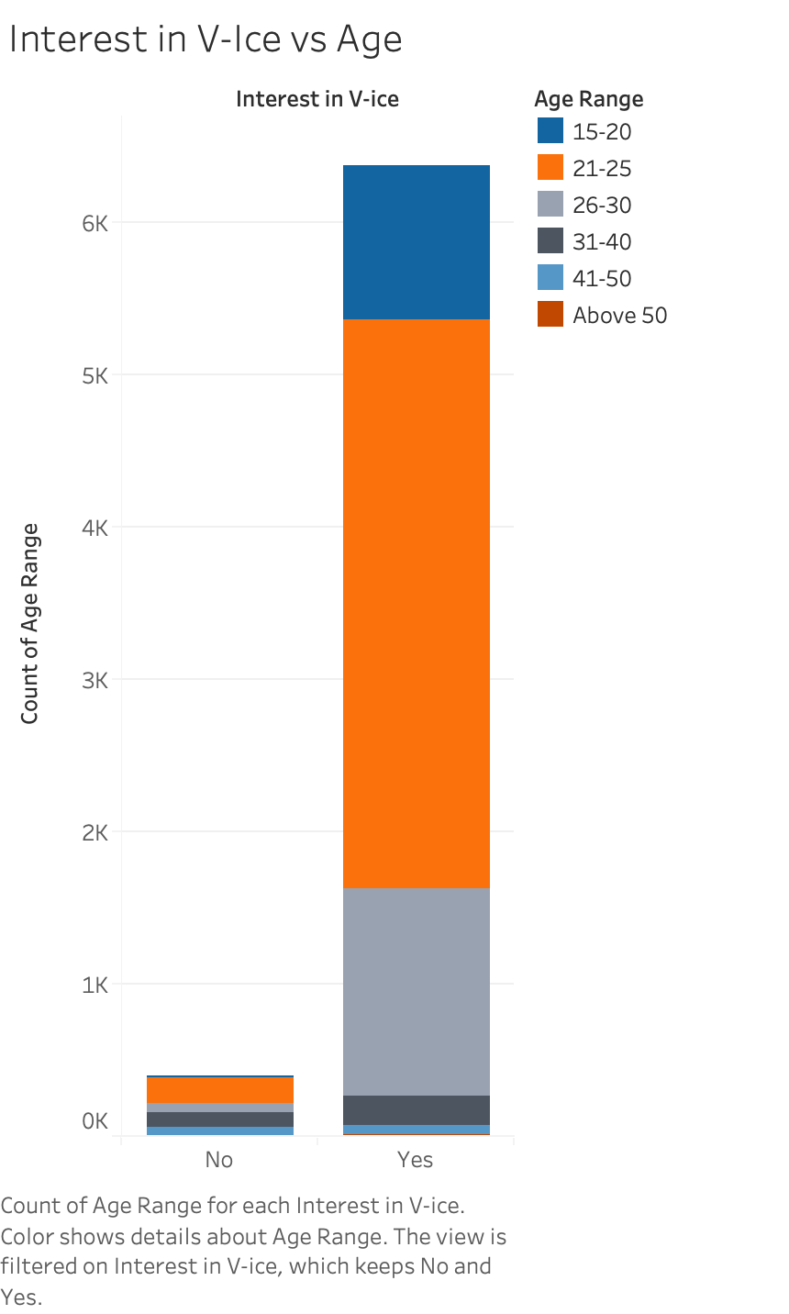

### 8.3 Flavors vs. Age

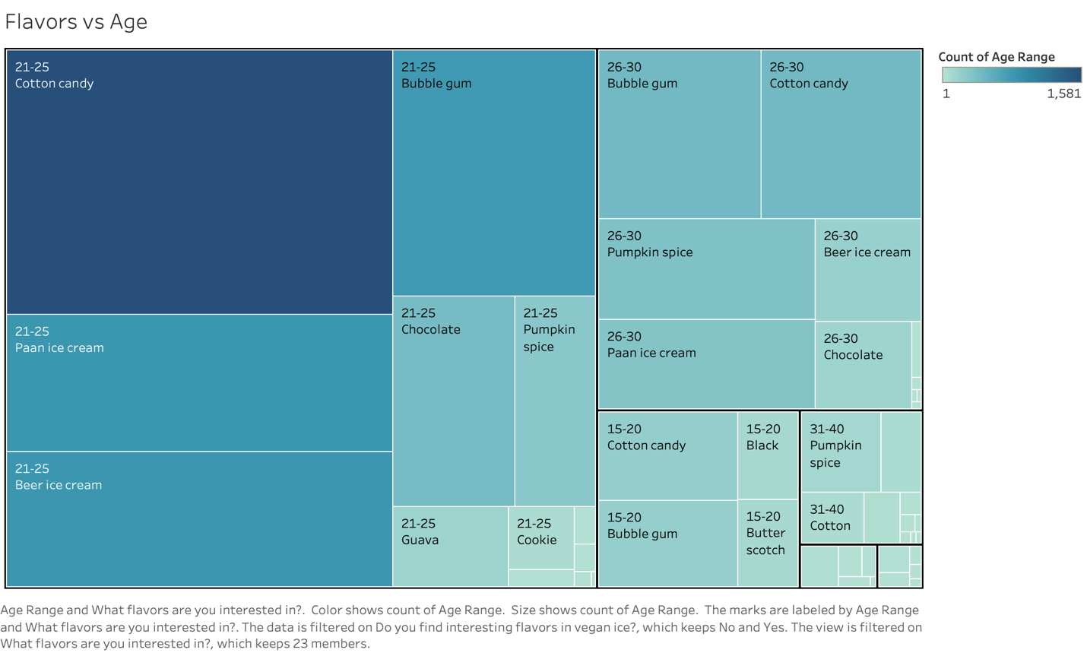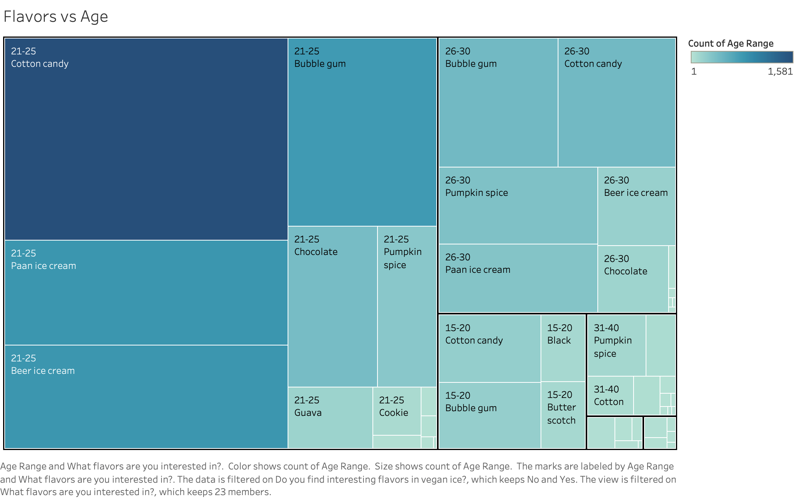

The above visual is pretty clear and self-explanatory that most of the people who have taken the survey are interested in trying out new flavors. This graph has given us positive results for the most important USP of our brand. The flavor cotton candy has the highest demand amongst all others which we planned to introduce, followed by bubblegum, pan flavor, beer ice cream, and others.

### 8.4 Age and time in a day

We were curious to know at what time people would like to have ice creams. From the below visualization, we can conclude that there are more people aged between 21 and 25 and most of them prefer to have their ice cream during midday and mid-nights. The next age group that are interested in having ice creams are between 26 and 30 who prefer to have ice creams during midnights. Maximum teenagers said that they would love to have ice creams during midnight only.

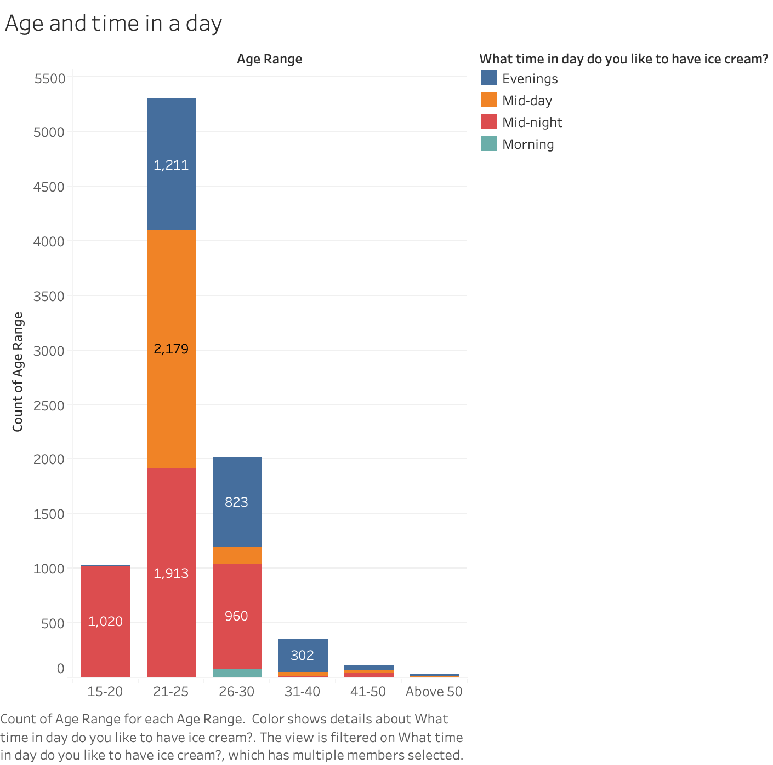

### 8.5 Quality, Gender vs. time, price

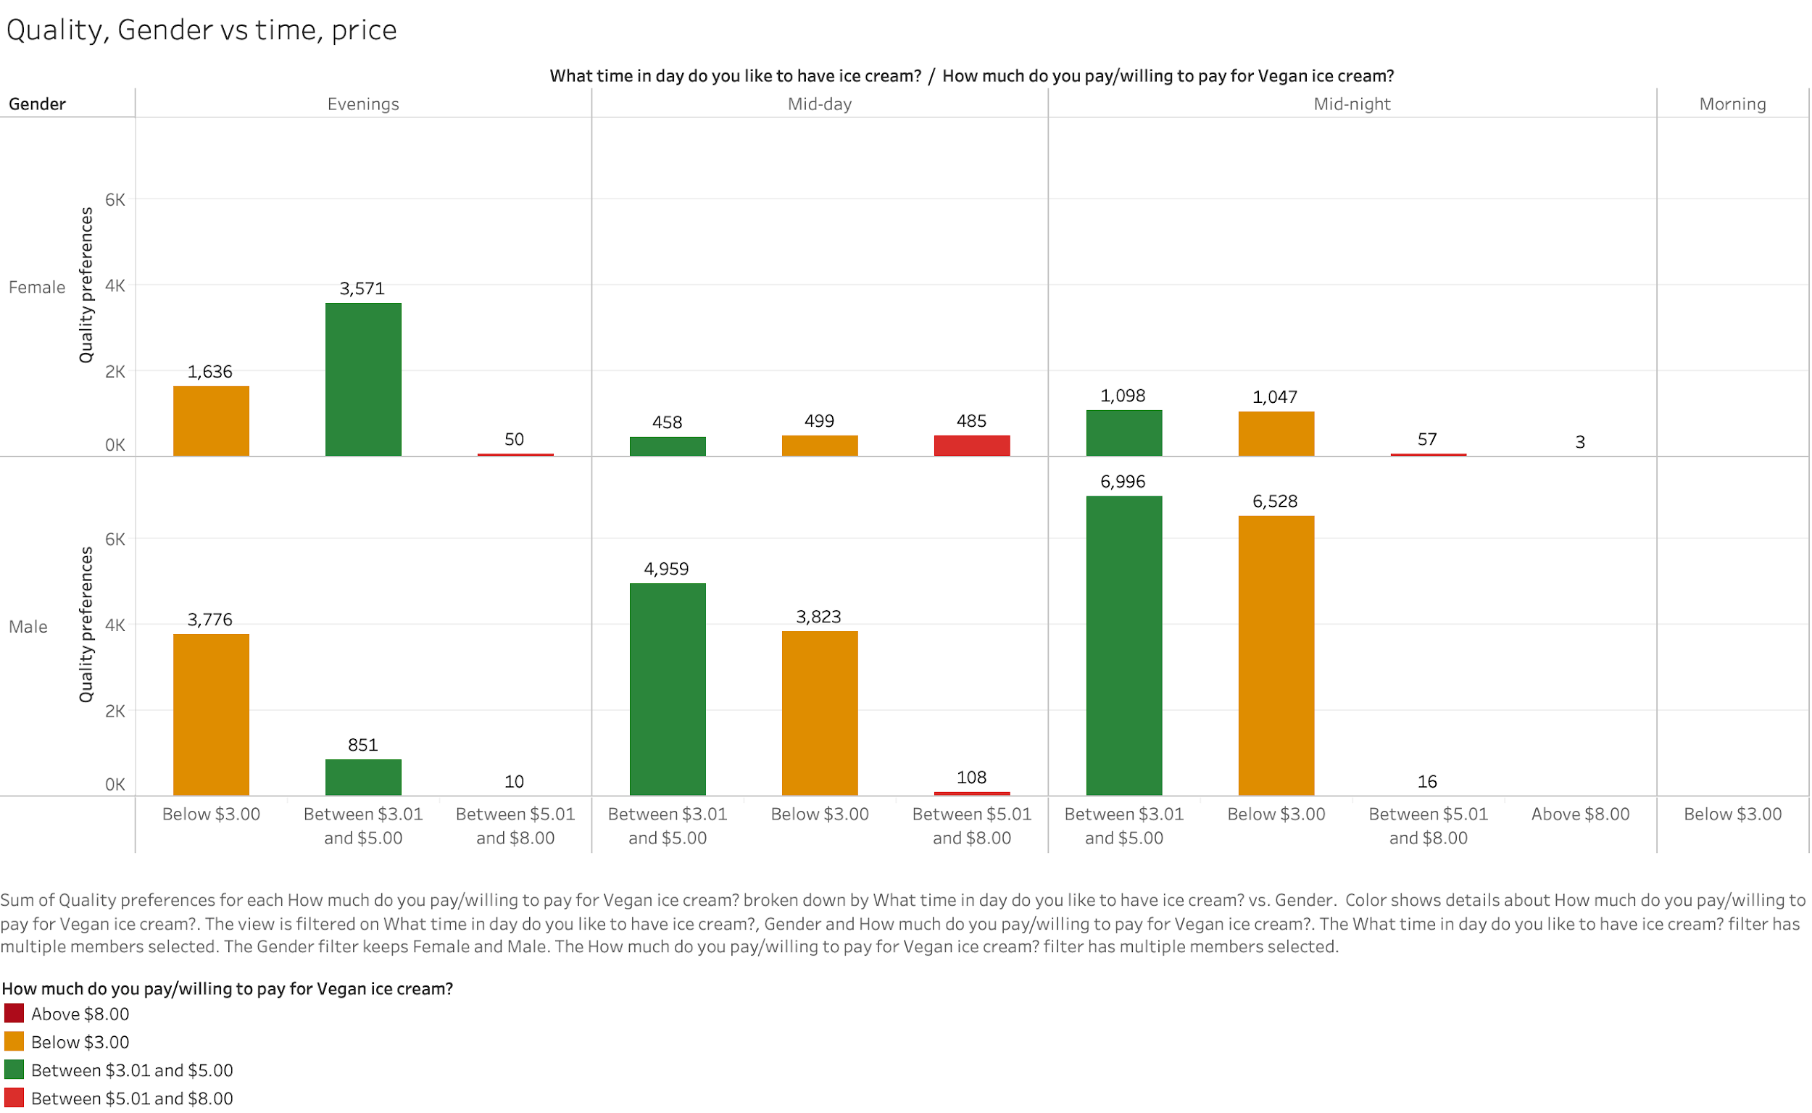

In the above graph we considered the quality, gender vs time and price, we can say that most of the females preferred to have an ice cream in the evening Whereas most of the males preferred to have an ice cream during mid-night. Also, most of the females are willing to pay between 3$ to 5$ per scoop and most of the males are ready to pay below $3.00 per scoop and no one is interested in having ice cream in the morning.

### 8.6 Location vs. Age

If we observe the below visualization, most of the people get their ice cream in parlors/ restaurants followed by supermarkets and mobile ice cream vendors. We also included the age factor to find out which age group buys more ice cream along with where they buy. So, from the visualization we can say that 21-25 age group people are more interested to buy ice cream in any of the locations mentioned.

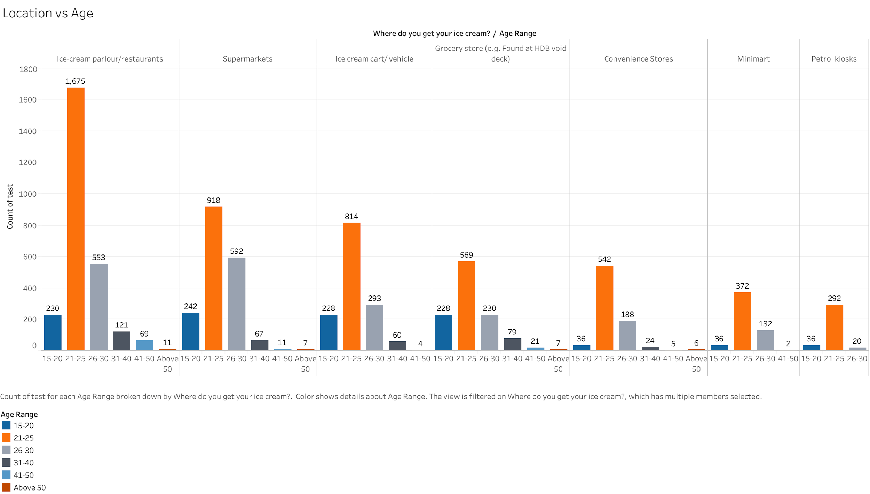

### 8.7 Competitors in Ice cream industry

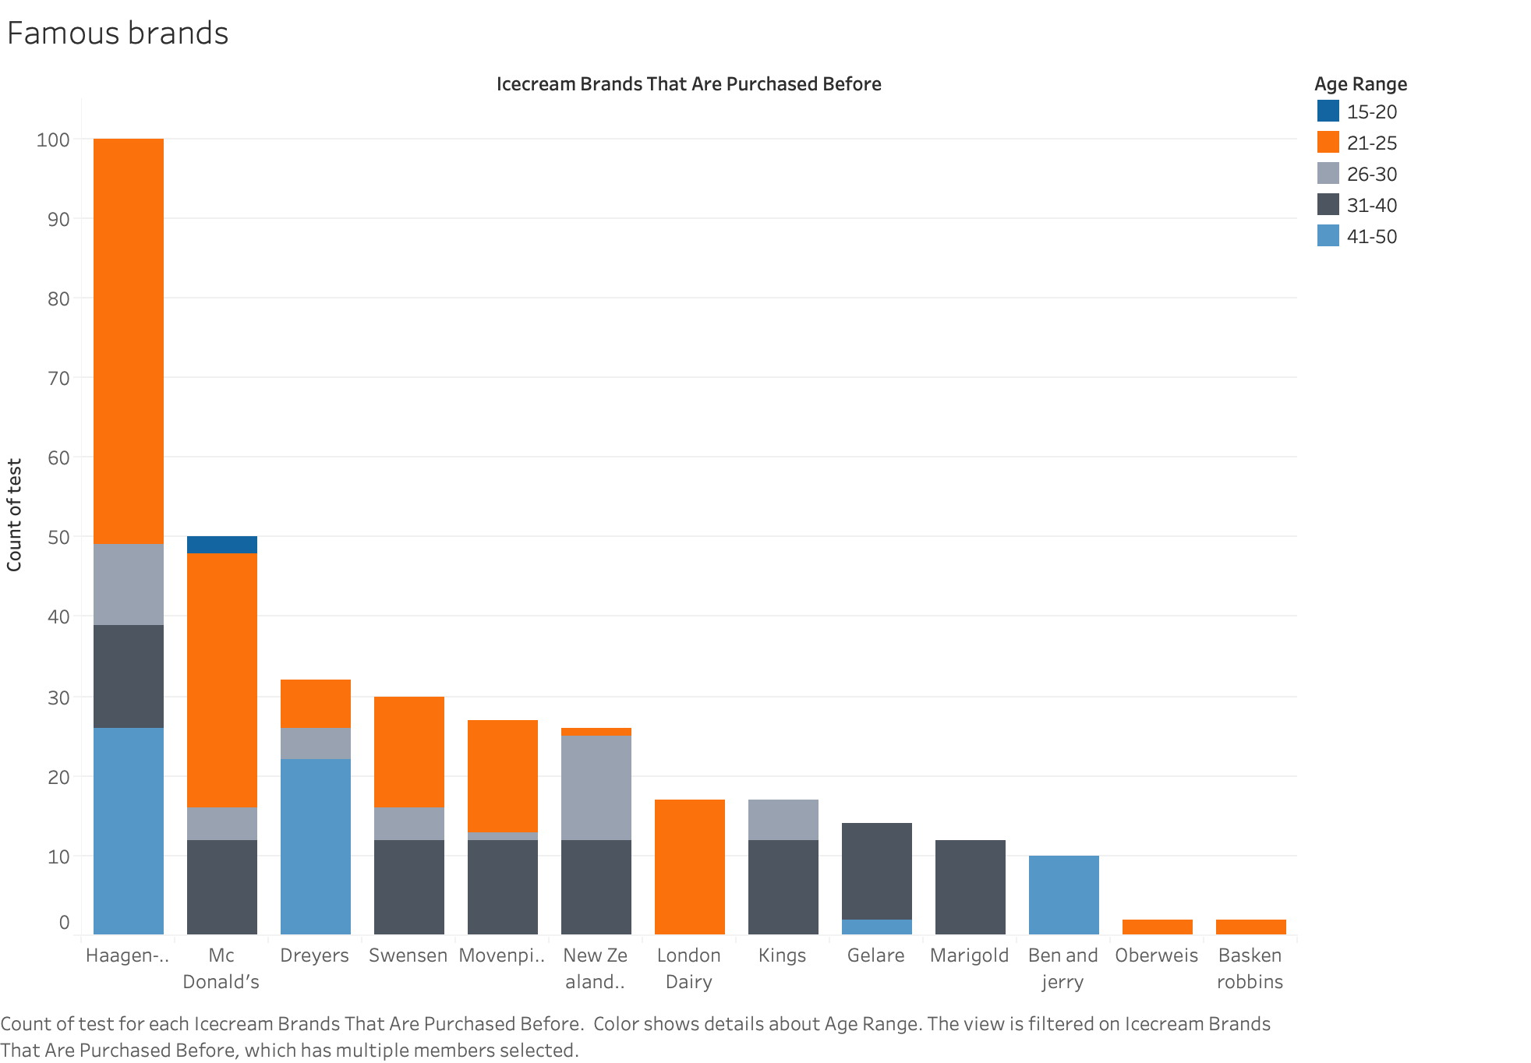

The above visualization talks about the current existing brands which are reputed for the ice creams they sell. We performed this visualization to know with whom we have to compete, to develop a strong business strategy. We will consider the top 3 brands as our primary competitors which are Haagen-Dazs, McDonald’s, Dreyer's. Leaving adolescents, all other age groups prefer the ice cream from Haagen-Dazs while leaving the older ones aged between 40 and 50, everyone likes ice cream from McDonald’s.

### 8.8 Age range vs. Base

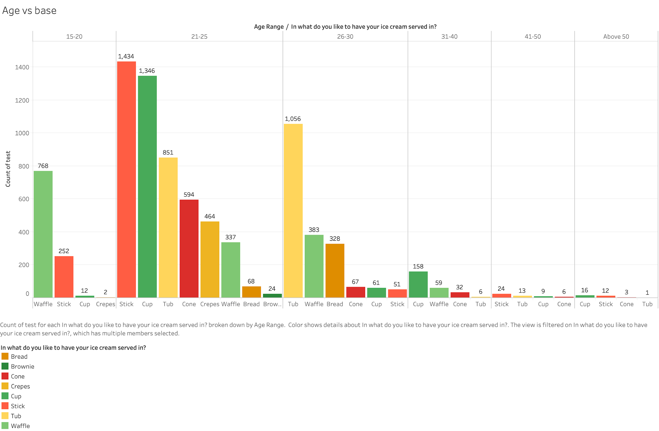

There are so many ways to serve ice cream. We love to have our ice cream in a tub. But it is not just about us, so we asked our customers what type of serving they like. Teenagers like to have their ice cream with a waffle. Young adults would give the highest preference to stick and cup. People aged 26-30 like it in a tub, and middle-aged people would like to have their ice cream in a cup. People aged above 40 years have no specific preferences in what they’d like to have their ice cream in.

### 8.9 Availability vs. Interest in V-Ice

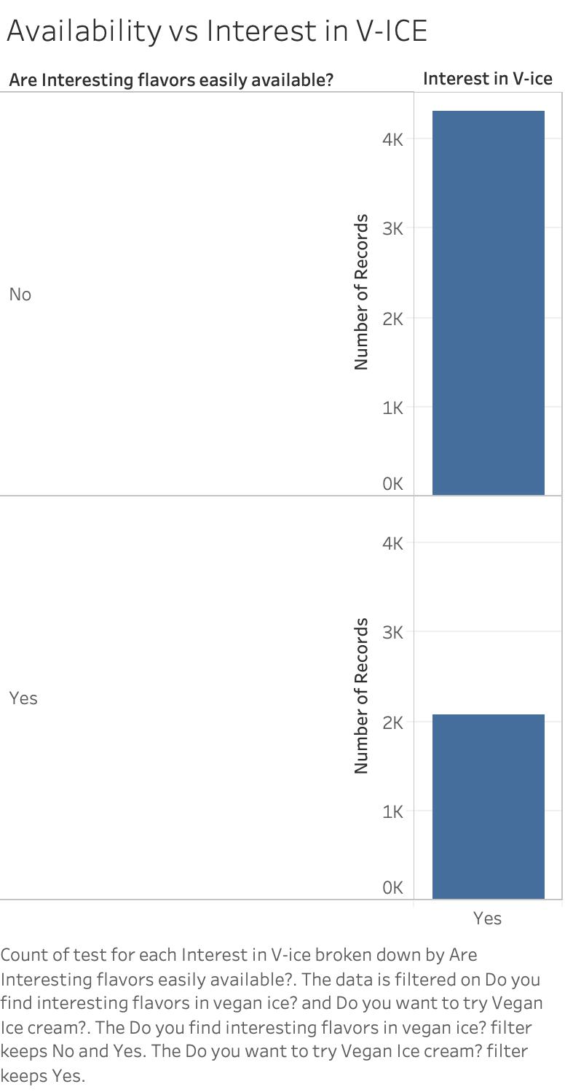

In this visualization we have asked the people who are interested in vegan ice creams, about the availability of it in the nearby stores. This is an important graph as we understand that the people interested in vegan ice cream claim that the availability of vegan ice creams is very scarce in their nearby stores.

### 8.10 Choice of Toppings vs. Age range

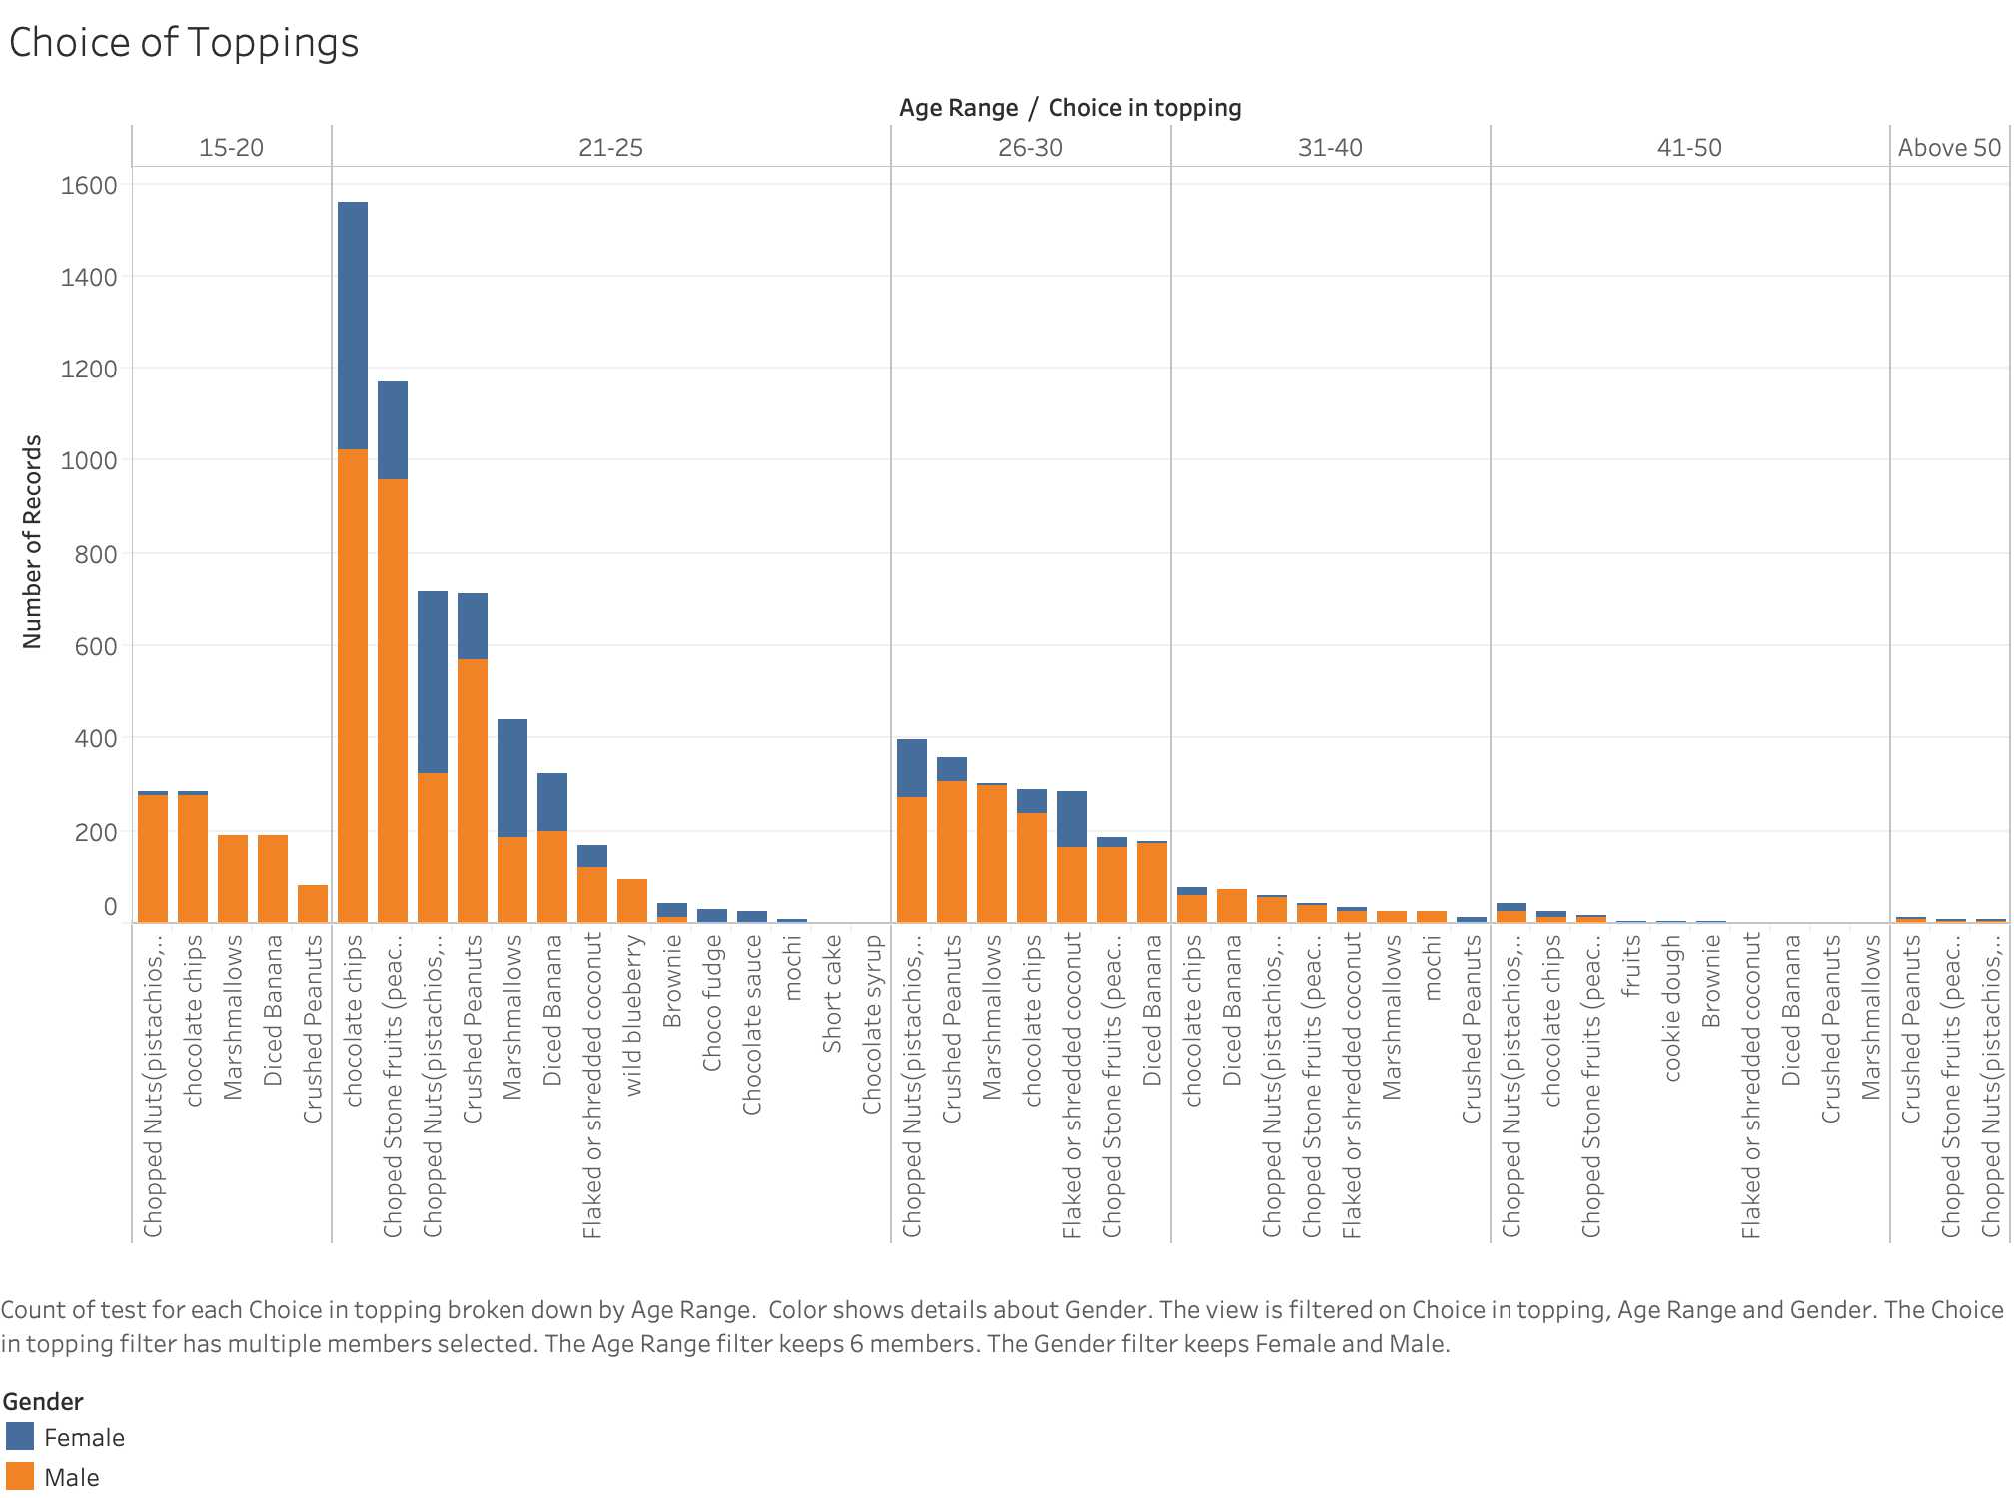

This visualization says that the males within the age group 21-25 are more interested in having the ice cream toppings. And among all the toppings listed, a large proportion of males preferred to have chocolate chips followed by chopped stone fruits like peaches, cherries, apricots and chopped Nuts. Also, the people within the age of 41-50 and above 50 are less interested in having the ice cream toppings.

### 8.11 Milk base vs. Gender

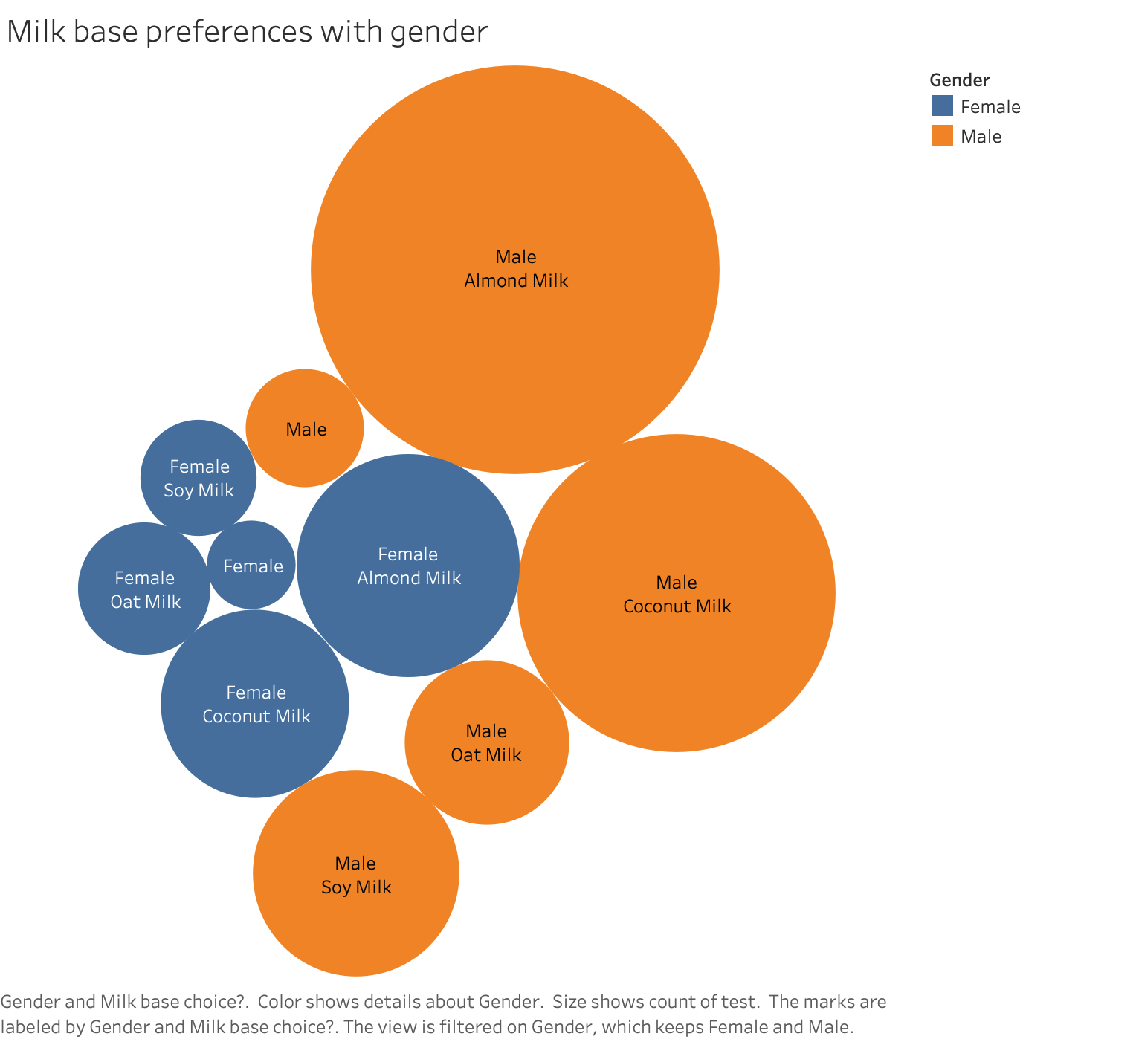

As we already discussed, there are many options available in vegan milk. So, what kinds of milk should we use to make our ice creams? To match their tastes, we also gathered the vegan milk preferences/ choices of our customers. We got to know that most of the male and female prefer almond milk first and then coconut milk. Third preference for male is the soymilk whereas it stands fourth for females, oat milk being their third which is fourth for male.

### 8.12 Promotions vs. Gender

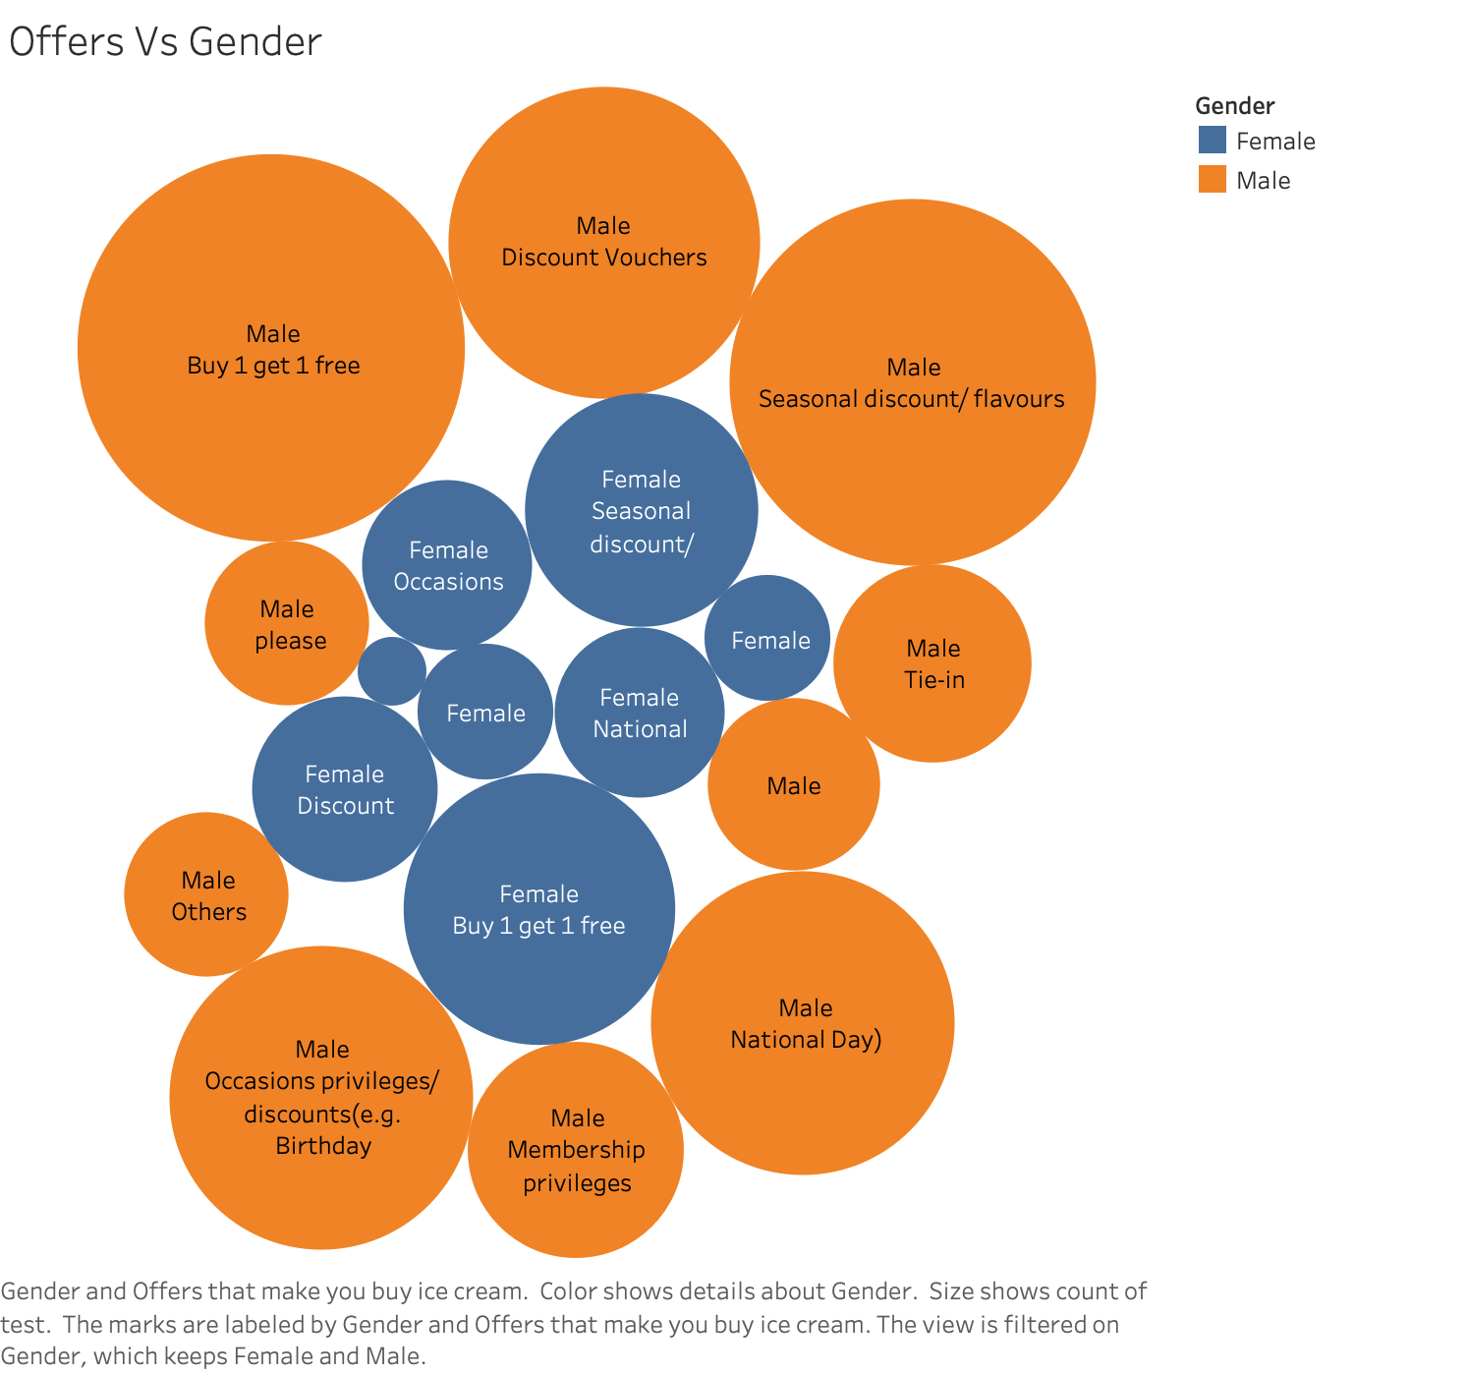

Do you get attracted to promotional offers on ice creams? We think it’d be a yes. Males show more interest towards the offers such as BOGO, vouchers, seasonal discounts where females show lesser interest in offers than that of males.

### 8.13 Interest in V-Ice vs. Quality, Promotions and Price

The below visualization displays the responses to the question "Are you interested in trying a Vegan ice cream?” by both the genders. Upon answering either a ‘Yes’ or a ‘No’, they were asked to choose the preferences that might interest them in trying the Ice Cream. The list of preferences includes price, quality, and Promotions. Turns out that both male and female give the first preference to the quality of the ice cream. Male give the second preference to promotional offers and discounts whereas females regardless of offers just want to have ice cream. So, they give the least preference for discounts.

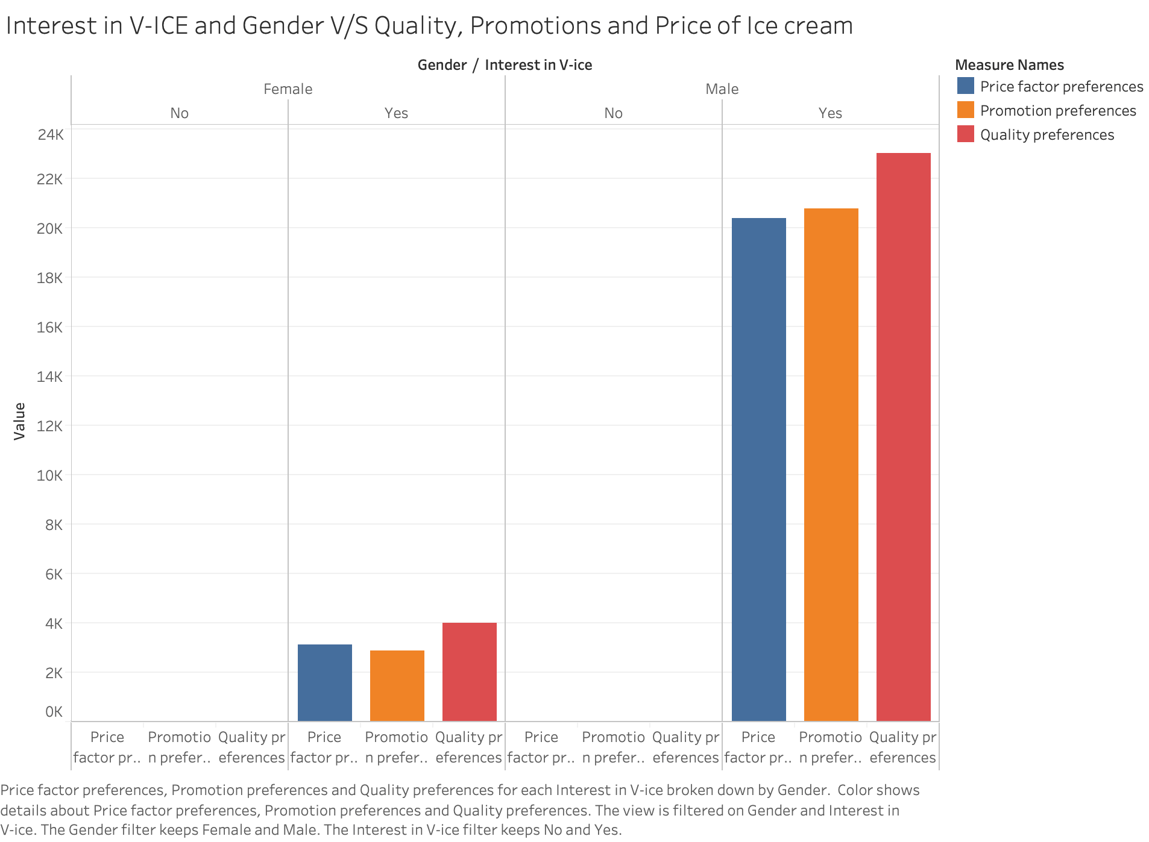

## 9. NEW FLAVOR IDEAS

Taking the survey results into consideration and our customers' interest in us, we wanted to stand out by amping up the expectations of our customers by unveiling our newest flavors made out of natural flavors and premium extracts. The below flavors are our main flavors, paan ice cream being the introductory flavor which will be the face of Vega-ice.

### 9.1 Cotton candy

It is a flavor that has a history of over 120 years. It is made out of the natural extracts of blue raspberry and pink vanilla. It's going to be one of our iconic flavors. (No Churn Cotton Candy Ice Cream Recipe | No Churn Ice Cream Recipes, n.d.) , (Flavor investigator: cotton candy, n.d.)

### 9.2 Bubble gum

Our key goal is to bring the natural tastes to our ice creams, so we made use of the milk base and infused it with the highly concentrated bubblegum extracts and essential natural oils.

(Herrera, 2020)

### 9.3 Pumpkin spice

To bring the best taste of this flavor, we make use of the pumpkin puree to maintain the originality, natural sugars extracted from fruits, and a vegan milk base preferably coconut milk. This ice cream would mostly be a seasonal flavor and can be savored the best in the fall season.

(Pumpkin Spice Ice Cream (no churn), n.d.)

### 9.4 Paan ice cream

Paan (also called betel quid) is usually an Indian after-dinner treat which is made of betel leaf filled with a variety of nuts, areca nuts, slaked lime, fennel seeds and many other ingredients. It gives a refreshing taste after a meal. It looks so natural and vegan, our idea is to crush it into granules, mix it with a vegan milk base and make ice cream out of it. (Manali, 2018) , (Siciliano-Rosen, n.d.)

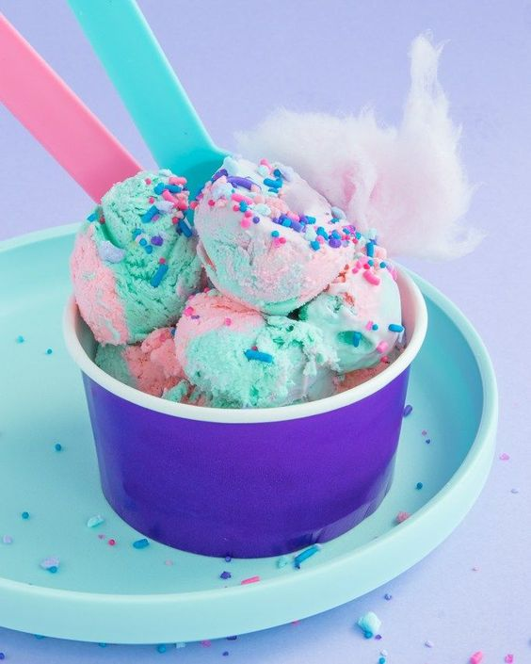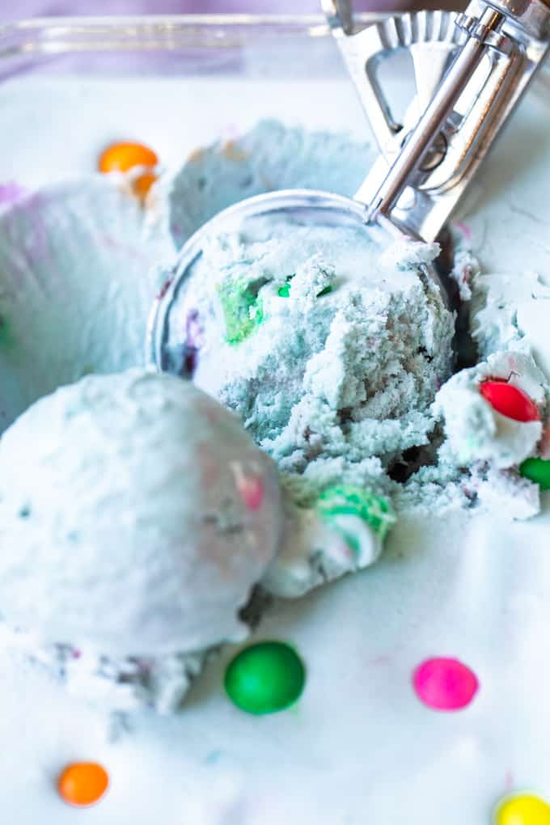

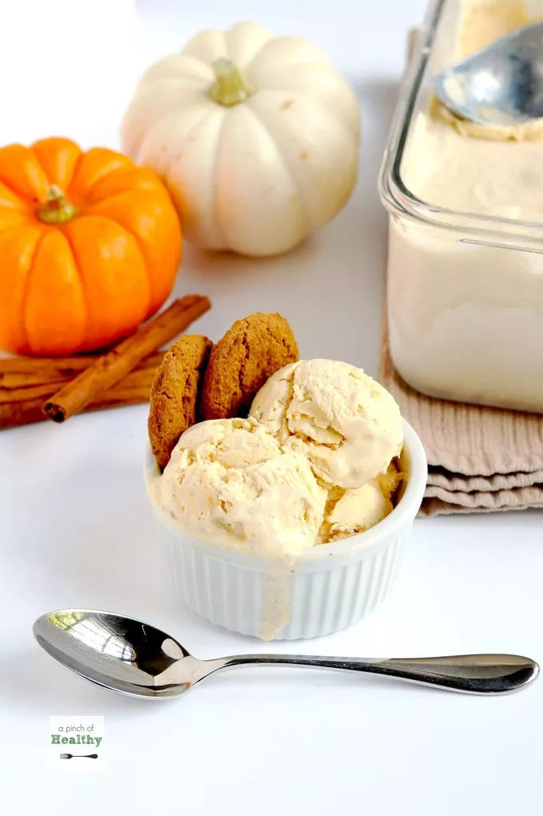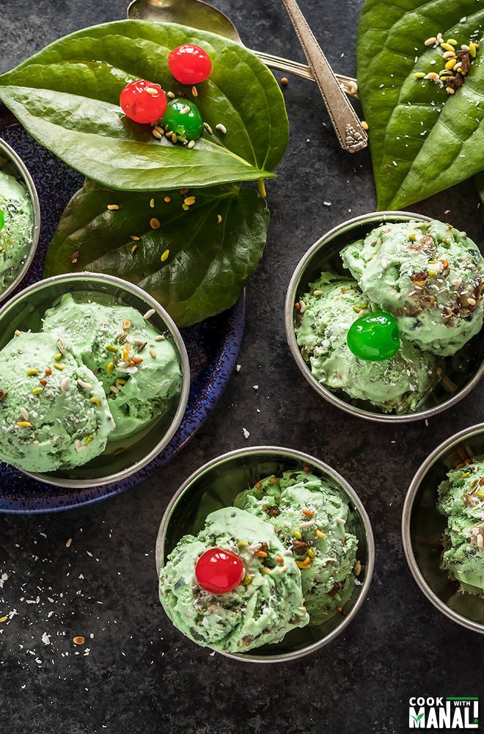

## 10. FINAL RECOMMENDATIONS

With all the analysis we can conclude that:

• Good number of people are interested in Vegan ice creams

•Age group 21- 25 is highly interested in trying new vegan flavors

•Quality is the primary constraint.

•Promotional offers are highly preferred

•New flavors are encouraged by most Age groups

•Vegan ice creams are not easily available

•Almond Milk and coconut milk is highly preferred

•Ice creams are mostly consumed mostly later in the evenings

•Price range per scoop is preferred to be between $3-$5

•Everyone loves toppings (Especially when they are cheap)

## 11. LIMITATIONS

Ice cream market has its own limitations which are as follows.

* Equipment costs would be high.
* Ice cream price per scoop should be lower than other vegan brands.
* Ice cream must have no more than 100% overrun (amount of air that is whipped into the ice cream base during freezing) and weigh no less than 4.5 lbs. per gallon.
* Strictly following all food and hygiene guidelines and regulations.
* Store demographic needs to be thoroughly discussed.
* Reduce high sugar levels in ice creams and usage of natural sugars in fruits.

## 12. CONCLUSIONS

With the Marketing research conducted we have observed that there are various features that are expected by the customers to consume a vegan ice cream. In this research we have understood that the global market share for vegan ice cream is huge and is only going to grow in the coming years. It is quite interesting how millennials have contributed to most of the vegan market in the US. To launch a new ice cream brand namely VEGA-ICE would need us to be mindful of various factors for it to be a successful business.

Some of these factors have been listed below:

* Distinct and interesting ice cream flavors
* Pocket friendly and an affordable brand
* Reduced sugar content and usage of natural sugars extracted from fruits
* Readily available in nearest stores
* Quality of ice cream is our top priority
* Toppings at affordable price

## 13. REFERENCES

abillionveg. (2020, January 11). *Why Go Vegan?* Retrieved from abillionveg: https://www.abillionveg.com/articles/why-go-vegan

Deshmukh, R. (2017, June). *Ice Cream Market Outlook - 2023*. Retrieved from Allied Market Research: https://www.alliedmarketresearch.com/ice-cream-market

*Flavor investigator: cotton candy*. (n.d.). Retrieved from My food job rocks: https://myfoodjobrocks.com/cotton-candy/

Guy, M. R. (2020, July 07). *The Market Research Process: 6 Steps to Success*. Retrieved from My Market Research Methods: https://www.mymarketresearchmethods.com/the-market-research-process-6-steps-to-success/

Herrera, S. (2020, May 23). *homemade bubblegum ice cream*. Retrieved from house of yumm: https://houseofyumm.com/homemade-bubblegum-ice-cream/

*Ice cream*. (n.d.). Retrieved from Wikipedia: https://en.wikipedia.org/wiki/Ice_cream

Manali. (2018, April 12). *Easy Paan Ice Cream*. Retrieved from cook with manali: https://www.cookwithmanali.com/easy-paan-ice-cream/

*No Churn Cotton Candy Ice Cream Recipe | No Churn Ice Cream Recipes*. (n.d.). Retrieved from Pinterest: https://in.pinterest.com/pin/214906213458023694/?nic_v2=1a6vlarG

*Pumpkin Spice Ice Cream (no churn)*. (n.d.). Retrieved from A Pinch of healthy: https://www.apinchofhealthy.com/pumpkin-spice-ice-cream-no-churn/

Siciliano-Rosen, L. (n.d.). *Paan*. Retrieved from britannica: https://www.britannica.com/topic/paan

*Why go vegan?* (n.d.). Retrieved from The Vegan Society: https://www.vegansociety.com/go-vegan/why-go-vegan#:~:text=Going%20vegan%20is%20a%20great,beneficial%20fibre%2C%20vitamins%20and%20minerals.